





Case Study Report

Data Analytics with Power BI

“ IPL AUCTION DATA ANALYSIS”

“Bishop Ambrose College”

| NM ID | NAME |
| --- | --- |
| 287F44805F957A695B545D9E8A78DD8D | B.Gokul |

| R UMAMAHESHWARI |  |
| --- | --- |
|  | Trainer Name |
| R UMAMAHESHWARI | Master Trainer |

ABSTRACT

The Indian Premier League (IPL) auction stands as aunique spectacle in the world of cricket, where franchises compete fervently to acquire players for their teams. This study delves into the intricate of the IPL auction, exploring the multifaceted interplay of market forces, player valuation methodologies, and strategic bidding strategies employed by franchise owners. Through an analysis of historical auction data and interviews with key stakeholders, this research aims to uncover the underlying factors driving player valuations, the impact of team composition on auction strategies, and the role of financial constraints in shaping bidding behaviors. Furthermore, the study seeks to shed light on the evolving nature of the IPL auction ecosystem, including the influence of player performance, international market trends, and regulatory frameworks on auction dynamics. By providing insights into the complexities of the IPL auction, this research contributes to a deeper understanding of the intersection between sports, economics, and strategic decision-making in the context of professional cricket leagues.

INDEX

| Sr. No. | Table of Contents | Page No. |
| --- | --- | --- |
| 1 | Chapter 1: Introduction | 1 |
| 2 | Chapter 2: IPL Auction Strategy | 3 |
| 3 | Chapter 3: Auction Data in IPL | 6 |
| 4 | Chapter 4: Data Visualization | 9 |
| 5 | Conclusion | 15 |
| 6 | Future Scope | 16 |



# INTRODUCTION

CHAPTER -1

INTRODUCTION

The Indian Premier League (IPL) is a professional league for Twenty20 cricket championship in India. It was initiated by the Board of Control for Cricket in India (BCCI), headquartered in Mumbai and is supervised by BCCI Vice President Rajeev Shukla, who serves as the league's Chairman and Commissioner. It is currently contested by nine teams, consisting of players from around the world. It was started after an altercation between the BCCI and the Indian Cricket League

In 2010, IPL became the first sporting event ever to be broadcast live on YouTube in association with Indiatimes. Its brand value is estimated to be around US$2.99 billion in fifth season

The IPL works on a franchise-system based on the American style of hiring players and transfers. These franchises were put for auction, where the highest bidder won the rights to own the team, representing each city. The auction for the same took place on January 24, 2008 and the total base price for the auction was $400 million. The auction went on to fetch $723.5million.

The Mumbai franchise owned by Mukesh Ambani's Reliance Industries Limited (RIL) was the most expensive franchise - fetching $111.9 million closely followed by Vijay Mallya's United Breweries which paid $111.6 million for the Bangalore franchise. Media house Deccan Chronicle won the Hyderabad chapter of the IPL for $107 million, while India Cements' Chennai franchise cost $91 million.

Bollywood also made its presence felt with two of its leading stars bagging the ownership of their respective teams Shah Rukh Khan and Juhi Chawla's Red Chillies Entertainment buying out Kolkata for $75.09, while Preity Zinta and her beau Ness Wadia bought the Mohali team for $76 million.

GMR, the infrastructure development group which who are involved in projectfor revamping the Delhi airport, bagged the ownership of the Delhi team for $84million and the Emerging Media, consisting of its CEO Fraser Castellino, ManojBadale and Lachlan Murdoch and other investors won the rights for the Jaipur franchise for $67 million.

On 21 March 2010, Pune and Kochi were unveiled as the two new franchises for the fourth edition of the Indian Premier League. The base price was $225 million. While Pune was bought by Sahara Adventure Sports Group for $370 million, the Kochi franchise was bought by Rendezvous Sports World Limited for $333.3 million. The process was to have been completed on 7 March but was postponed by two weeks after many bidders and the BCCI objected to stiff financial clauses. The second franchise auction fetched total $703 million.

CHAPTER 2

AUCTION STRATEGY

IPL auction strategy involves:

Budget Allocation: Teams decide on their budget for the auction, keeping in mind the need to acquire players across various positions while staying within financial constraints.

Identifying Squad Requirements: Teams assess their current squad and identify areas that need strengthening or where they lack depth.

Player Targeting: Teams identify specific players or player types they wish to acquire, considering factors like performance, suitability to team strategy, and market value.

Flexibility: Teams remain flexible during the auction to adapt to changing dynamics, such as competing bids and unexpected availability of players.

Balancing Marquee Players and Emerging Talent: Teams aim to strike a balance between acquiring established, high-profile players and investing in promising young talent to build a competitive and sustainable squad.

Strategic Bidding: Teams strategically bid for players, considering their budget, the value they bring to the team, and the potential impact on the squad dynamics.

Overall, the goal is to build a balanced and competitive team within the allocated budget while maximizing the value of each player acquisition.

.

CHAPTER -3

AUCTION DATA IN IPL

IPL auction data typically includes information such as:

1. Player Details: Name, playing role (batsman, bowler, all-rounder), nationality, age, past IPL performances, and base price set by the player.

2. Bidding Information: Bids placed by teams for each player, the winning bid, and the team that acquired the player.

3. Team Budgets: Each team's remaining budget throughout the auction process.

4. Player Categories: Players are often categorized into marquee players, capped players (those who have represented their national team), uncapped players (those who haven't represented their national team), and overseas players.

5. Auction Rounds: Information on the different rounds of the auction, including any retention or right-to-match cards used by teams.

This data provides insights into the strategies employed by teams, player valuations, and the overall dynamics of the auction process. It's valuable for analysis, understanding market trends, and assessing team compositions post-auction.

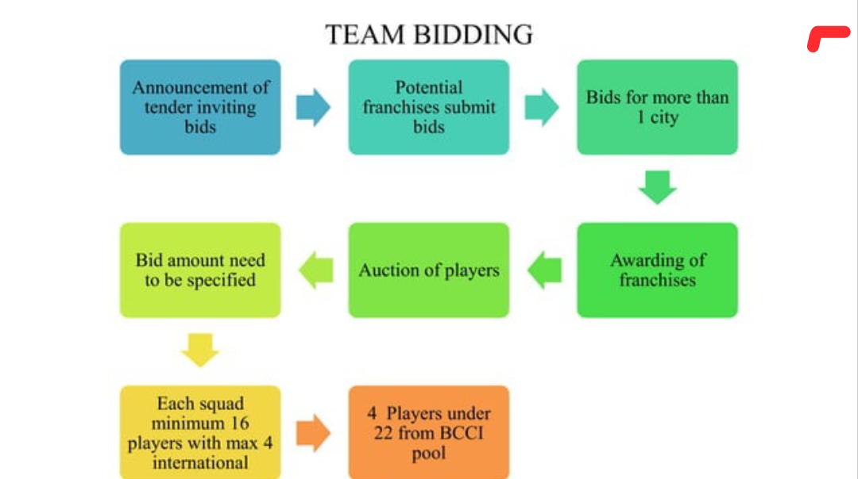



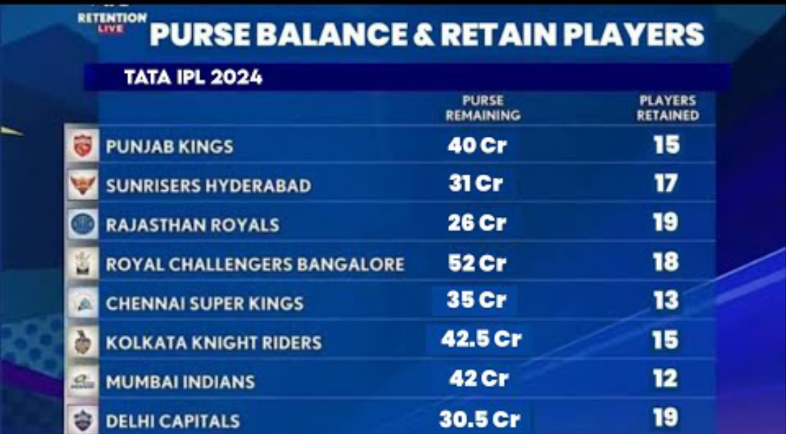

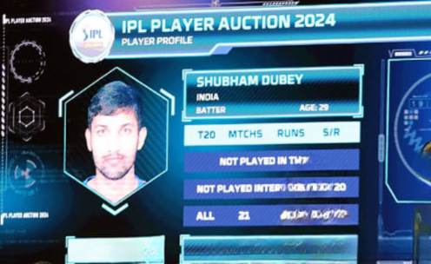

# CHAPTER 4

DATA VISUALIZATION

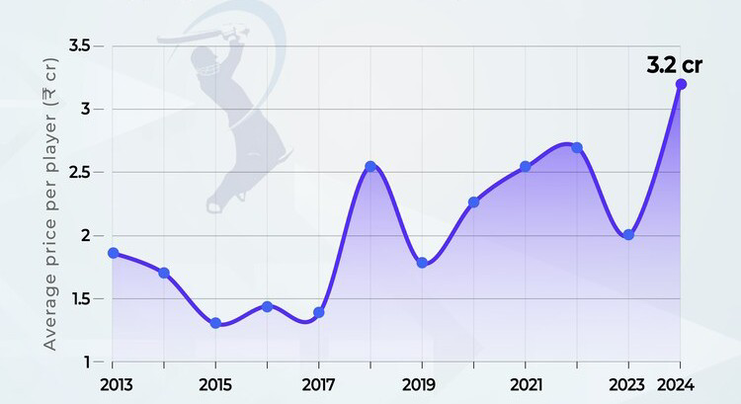

* + - Bar graph

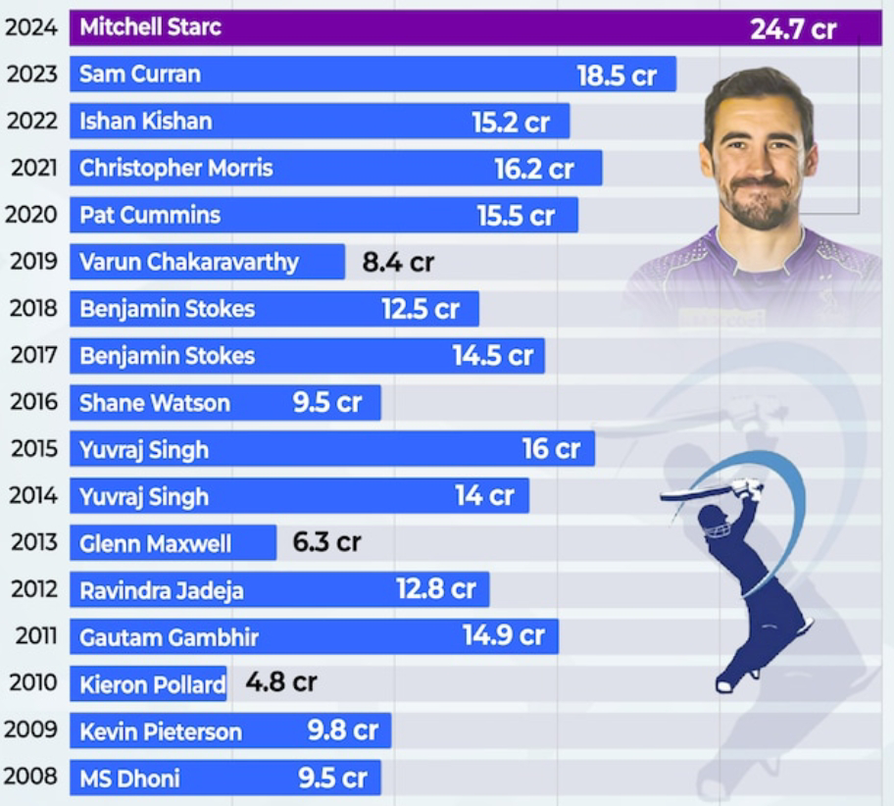

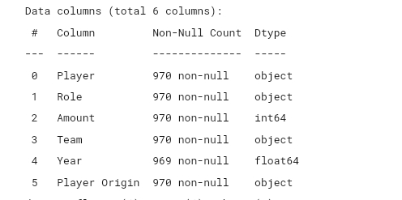

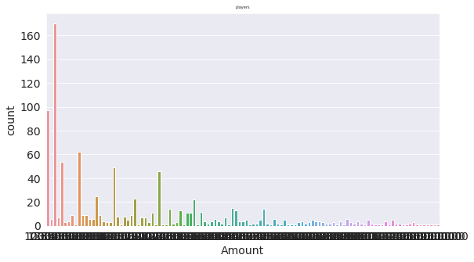

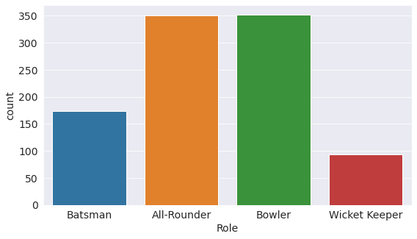

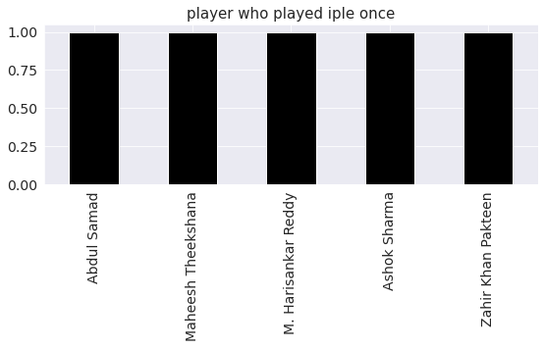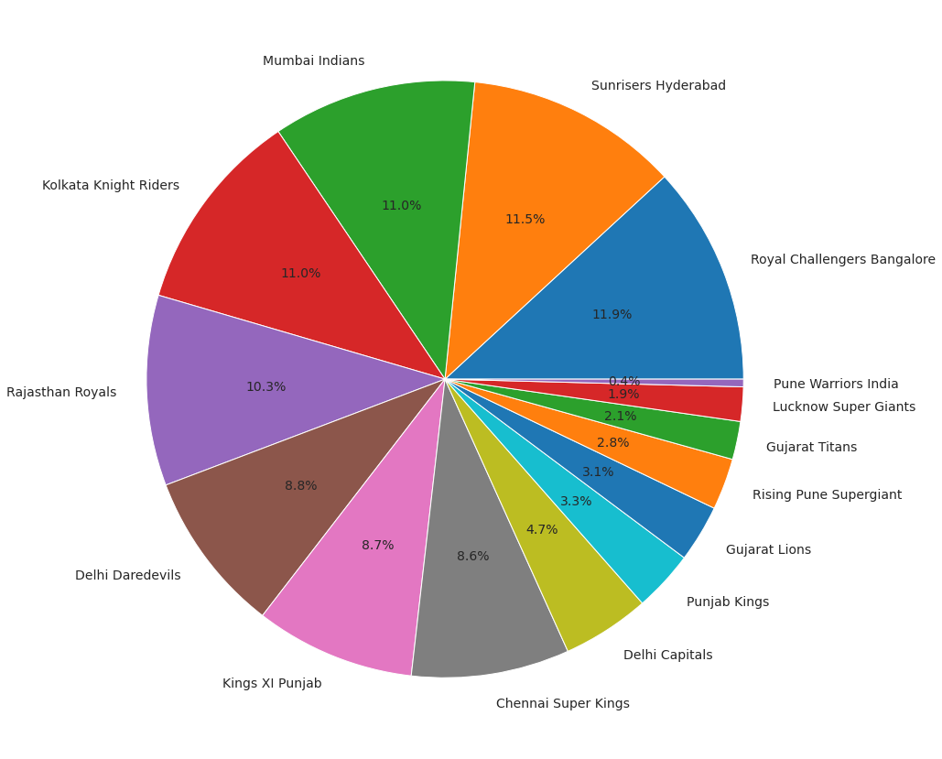

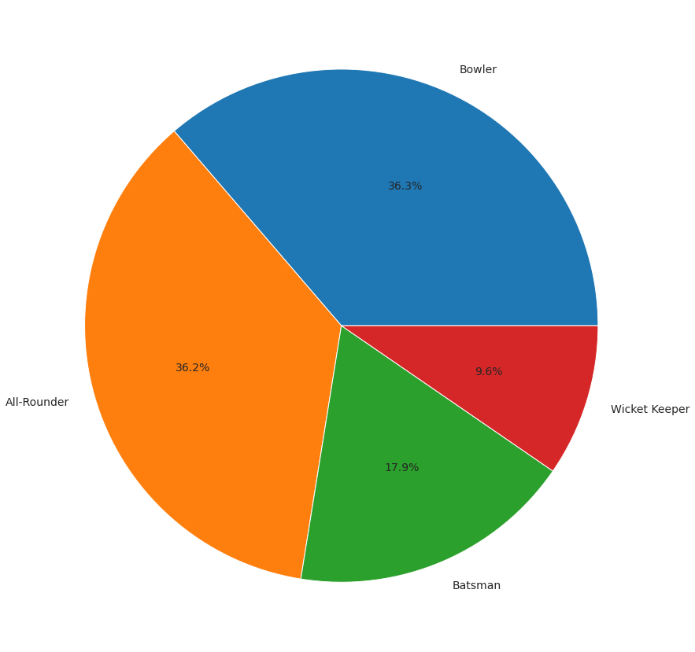

# CONCLUSION

The conclusion of an IPL auction analysis depends on various factors such as team strategies, player performances, and market trends. However, some common conclusions could include insights on which teams strengthened their squads, which players fetched the highest bids, and how teams balanced their budgets to build competitive rosters. Additionally, analyzing trends in player preferences, bidding patterns, and team dynamics can provide valuable insights into the evolving strategies of IPL franchises.

# FUTURE SCOPE

The future scope of IPL auction analysis could involve advanced data analytics techniques, such as machine learning algorithms, to predict player performance and value for money. It could also expand to include deeper analysis of team strategies, financial implications, and the impact of auction decisions on team performance and franchise economics. Additionally, integrating real-time data and social media sentiment analysis could provide valuable insights for teams and stakeholders. As technology evolves, there's potential for virtual/augmented reality simulations to enhance decision-making processes during auctions.

**References**

[1] Parker, D., Burns, P., & Natarajan, H. Player valuations in the Indian Premier League, Frontier Economics, 2008,1-17

[2] Gunjan Kumar. Machine Learning for Soccer Analytics. 2013

[3] Madan Gopal Jhawar & Vikram Pudi. Predicting the Outcome of ODI Cricket Matches: A Team Composition Based Approach, European Conference on Machine Learning and Principles and Practice of Knowledge Discovery in

[4] Databases, 2016

[5] Abel Hijmans. Dutch football prediction using machine learning classifiers

[6] C. Deep Prakash, C. Patvardhan & Sushobhit Singh. A new Machine Learning based Deep Performance Index for Ranking IPL T20 Cricketers, International Journal of Computer Applications 137(10):42-49, March 2016

[7] P. Kalgotra, R.Sharda, G.Chakraborty, Predictive Modelling in Sports Leagues:An application in Indian Premier League, SAS Global Forum, 2013

[8] P.K. Dey, D. N. Ghosh, A.C. Mondal. Multi-Criteria Decision Tree Approach to Classify All-Rounder in Indian Premier League, Journal of Emerging Trends in Computing and Information Sciences, 2011. 2 (11), 563-73 [9] https://www.crummy.com/software/BeautifulSoup/#Download [10] http://pandas.pydata.org/ [11] https://www.tableau.com/ [12] Christopher Bishop. Pattern Recognition and Machine Learning. 2e.